Application for the Approval of an Incremental Capacity Project according to Article 28 (1) NC CAM on the border between Poland TGPS
and
Germany (Trading Hub Europe)

28 October 2020

The application for an incremental capacity project for the market border of Poland TGPS (Transit Gas Pipeline System) and Germany (Trading Hub Europe) has to be approved by the respective national regulatory authority. This document presents a project proposal for the interconnection point Mallnow, as prepared by:

GASCADE Gastransport GmbH. | Operator Gazociągów Przesyłowych  GAZ-SYSTEM S.A.
Kölnische Str. 108-112 | Ul. Mszczonowska 4
34119 Kassel | 02-337 Warsaw
Germany | Poland

According to Article 28 (1) NC CAM, following the consultation and finalisation of the design phase for an incremental capacity project in accordance with Article 27, the involved transmission system operators shall submit the project proposal for an incremental capacity project to the relevant national regulatory authorities for coordinated approvals. GASCADE submits this proposal for an incremental capacity project for the market border of Poland TGPS and Germany (Trading Hub Europe) to the Bundesnetzagentur (BNetzA) and GAZ-SYSTEM submits this proposal to the President of the Energy Regulatory Office (URE). The interconnection point (IP) Mallnow connects abovementioned adjacent gas transmission systems.

In this document the following abbreviations are used:
NC CAM = Commission Regulation (EU) 2017/459;
NC TAR = Commission Regulation (EU) 2017/460.

Table of Content
1. Introduction to the application of the project proposal for incremental capacity 5
2. Offer-level for incremental capacity (Art. 28 (1) (a) NC CAM) 8
2.1. Offer level (GASCADE) 8
2.2. Offer level (GAZ-SYSTEM) 10
3. Terms and Conditions for the Incremental Capacity Auction to be accepted by the network user for the acquisition of incremental capacity (Art. 28 (1) (b) NC CAM) 11
3.1. Terms and Conditions for the Incremental Capacity Auction on the German side of the border 11
3.2. Terms and Conditions for the Incremental Capacity Auction on the Polish side of the border 11
4. Timetable for the incremental capacity project (Art. 28 (1) (c) NC CAM) 11
5. Parameters of the economic test (Art. 28 (1) (d) in conjunction with Art. 22 (1) NC CAM) 18
5.1. Parameters of the economic test on the German side of the border 18
5.2. Parameters of the economic test on the Polish side of the border 22
6. Possible extended time horizon for contracting incremental capacity (Art. 28 (1)(e) NC CAM) 23
7. Alternative allocation mechanism (Art. 28 (1) (f) NC CAM) 23
8. Application of a fixed price approach (Art. 28 (1) (g) NC CAM) 23

Introduction to the application of the project proposal for incremental capacity

After completion of Phase 1 of the incremental procedure initiated in 2019 pursuant to NC CAM for creating incremental capacities at the market area border between the market area Trading Hub Europe (THE) and Poland TGPS (Transit Gas Pipeline System) the involved German transmission network operators (TSO) started the planning phase for the corresponding projects (Phase 2).
The stated enquiries for incremental capacity to be created in line with Art. 26 (8) (d) NC CAM include the requirement for a combined analysis. In the planning phase the involved TSO accordingly came to the conclusion to jointly analyse the stated enquiries for incremental capacity to be created. The determined measures are dependent on one another, therefore the analysis of individual enquiries with directly allocable measures is not possible and a joint realisation of the expansion measures is useful.
As presented in the Market Demand Assessment Report (MDAR) 2019 (published on 21 October 2019) there is a need for additional firm capacities for the market area border Poland TGPS and THE on the German side. The MDARs based on the received market demands are accessible to the public on the website of FNB Gas e. V and GAZ-SYSTEM respectively. The conclusion of the MDAR was that GASCADE will start a project for the creation of incremental capacity. Since the non-binding demand for incremental capacity between GASCADE and GAZ-SYSTEM was requested only on the German side of the border and capacities to a sufficient extent are already available on the Polish side of the market area border there was no need to conduct technical analysis on Polish side of the IP Mallnow and no project for development of incremental capacities was initiated by GAZ-SYSTEM. However, in line with NC CAM the consultation of the project proposal was carried out jointly so that the offer level for incremental capacity to be created on the German side can be offered as a bundled capacity.
Besides the non-binding enquiry for incremental capacity to be created at Mallnow IP presented above, a high number of further enquiries for incremental capacity to be created were received by the German TSO. The various possible combinations of the enquiries led to a multitude of modelling variants, which must have been carried out as a basis of the technical studies.
In addition, the planned merger of the German Entry-Exit-Systems into the joint German market area THE as of 1 October 2021 also has an influence on the existing capacity that is to be taken into consideration for the German incremental projects and consequently for hereby incremental project at Mallnow IP. Only approved technical capacity within the meaning of Section 9 Para. 4 S. 1 German Regulation on Access to Gas Supply Networks [Verordnung über den Zugang zu Gasversorgungsnetzen - GasNZV] (hereinafter "Basic Capacity") can be taken into consideration in the procedure for creating incremental capacities.
This circumstance leads to the fact that at the border between Poland TGPS and THE the request for incremental capacity to be created had to be adjusted once again after publication of the non-binding MDAR. In the non-binding MDAR for incremental capacity to be created it was noted in the comments that in total 27,828,000 kWh/h FZK should be achieved at the border. As compering to technical FZK from NEP 2020 capacity amounting to 17,512,000 kWh/h the Basic Capacity approved by BNetzA on 22 April 2020 at the IP Mallnow is 10,877,000 kWh/h FZK, this results in a difference of 16,951,000 kWh/h FZK to the requested capacity. For this reason, GASCADE has decided by coordination with the enquiring transport customer and the BNetzA to take 16,951,000 kWh/h into consideration as incremental capacity to be created over the further course of the project.
Within the scope of this project for incremental capacity to be created technical studies were conducted for all potential network interconnection points at the German market area border, for which the incremental project was initiated. Both financial aspects as well as the network topology are taken into consideration hereby. After completion of the technical studies the TSO concerned started the process for the design of the coordinated offer levels for the marketing of the capacity products including identified incremental capacity to be created.

Information on non-binding market demand
A technical study was conducted on the German side of the market area border Poland TGPS - THE on the basis of the adjustment to the demand for incremental capacity to be created described above. 16,951,000 kWh/h were analysed as incremental freely allocable capacity (FZK) to be created at the Entry to THE. A more detailed breakdown of the requested capacities as well as the at least equivalent existing capacities at interconnection points, TSO, products and Gas Years can be seen from Annex 2.

Public consultation of the draft project proposal and market responses
Comments from one market participant were received by GASCADE and GAZ-SYSTEM in the public consultation of the technical studies held from 10 August until 10 September 2020. Comments received referred to German aspects of the project proposal.
- Within the statement the question about the adjustment of the existing firm freely allocable capacity (FZK) from 17.512MWh/h to 10.877 MWh/h was asked. The adjustment of the existing FZK available for long-term booking is related to the merger of the two market areas NCG and GASPOOL. Within the current incremental capacity cycle this adjustment needs to be considered in order to assess reliable results from the technical studies needed. All information concerning the marker area merger in Germany can be seen under: www.marktgebietszusammenlegung.de
- An explanation was requested in the process of the cancellation of capacities based on the provision laid down in Article 5.3. in the published and consulted supplementary business terms and condition of GASCADE for new capacities to be created. Further information regarding this article will be part of the publication two months prior to the auction.
- It was also indicated that providing the information on mandatory minimum premium (MMP) after the auction puts a shipper in front of uncertainty regarding its costs. Thus, the shipper should know the costs – including a MMP – prior to taking decision on participating in the auction. NC TAR states that the range of the mandatory minimum premium needs to be submitted to the national regulatory authorities. In addition to the submission to the national regulatory authorities the range of the mandatory premium is included in the Annex 4 of the project proposal.
As comments did not refer to aspects of the project proposal on Polish side, GAZ-SYSTEM did not react to the provided comments.
Following the structure of Article 28 (1) NC CAM this application is structured as followed:
- Offer-level 1 of the incremental capacity (Art. 28 (1) lit. a) NC CAM),
- Terms and Conditions for the Incremental Capacity Auction to be accepted by the network user for the acquisition of incremental capacity (Art. 28 (1) li. b) NC CAM),
- Timetable for the project of incremental capacity (Art. 28 (1) lit. c) NC CAM),
- Parameters of the economic test (Art. 28 (1) lit. d) NC CAM),
- Information on a possible extended time horizon for contracting incremental capacity (Art. 28 (1) lit. e) NC CAM),
- Information on an alternative allocation mechanism (Art. 28 (1) lit. f) NC CAM),
- Information on a possible fixed price approach (Art. 28 (1) lit. g) NC CAM).

2. Offer-level for incremental capacity (Art. 28 (1) (a) NC CAM)

2.1. Offer level (GASCADE)

In the economic test pursuant to Art. 22 NC CAM it will be examined for an offer level whether the net present value of the total proceeds by bookings of incremental capacity to be created in the marketing in July 2021 ("Proceeds") at least correspond with the product of the f-factor with the net present value of the estimated increase in the admissible proceeds of the TSO, corresponding with the offer levels ("Costs"). In this process, there is only one offer level depending on the project proposal and therefore no competing offer levels.

Product design
Pursuant to Art. 3 (5) NC CAM an offer level refers to the amount of the existing and the incremental capacity to be created. In conjunction with Art. 29 (1) NC CAM an offer level must, if applicable, include several bundled standard capacity products (for example with several relevant network interconnection points (hereinafter "Interconnection Point" or "IP") between the market areas). The relevant capacities will be published in May 2021 as far as possible bundled standard products for each Gas Year, IP, TSO and product. The offer level is published on the website www.fnb-gas-capacity.de. The offer level comprises all incremental capacity products to be created as well as the existing capacity products, which must be booked as a prerequisite for the initiation of the economic test.

Potentially equivalent existing capacity products can be seen from Table 1. Their consideration is described in detail in the Section "Concrete offer level".
Case | Requested incremental capacity product to be created | Potentially equivalent or higher quality products  (at the requested IP/market area border)
1 | FZK | - FZK
2 | DZK with allocation to certain IP/market area borders | - FZK  - DZK with allocation to at least the requested IP/market area borders
Table 1: General case matrix of the products that are equivalent or of a higher quality compared to a requested capacity product

Marketing horizon
Pursuant to Art. 11 (3) S. 2 NC CAM offer levels, which include incremental capacity to be created, can be offered and booked for a period of up to 15 years after the forecast start of the operational use of the incremental capacity products. Here this corresponds with the period of time from the Gas Year 2027/2028 up to and including Gas Year 2041/2042.

Allocation methodology with existing products
In the marketing of the annual capacities in 2021 GASCADE is planning to market the existing capacity outside of the offer levels for the following five years. The existing capacities, which are relevant for the allocation of the offer level, will however be offered in the offer level including incremental capacity to be created. An overlapping of existing capacity auctions and bookings of the offer level can therefore be avoided.

Amount of the capacity to be offered
The calculation of the amount of the capacities to be offered per product will be carried out pursuant to Art. 11 (6) NC CAM. The reservation quota of 20% for existing as well as incremental capacities pursuant to Art. 8 (8) NC CAM in conjunction with the stipulation of BK7-15-001 of the BNetzA (hereinafter "KARLA Gas") will be taken into consideration.

Concrete offer level
The offer level 1 can be seen from Annex 2. The economic test is passed if 100% of the offered capacities are booked binding. The offer level comprises the following products:

- Existing capacity products
  - IP Mallnow
    - GASCADE: FZK
- Incremental capacity products to be created
  - IP Mallnow
    - GASCADE: FZK

2.2. Offer level (GAZ-SYSTEM)

Since the amount of technical capacity on the Polish side of the border at the level of 38 812 499 kWh/h is already sufficient to enable the incremental capacity on German side GAZ-SYSTEM will only refer to the part of the offer level which is planned to be marketed as bundled.

According to Article 28 (1) lit. a) NC CAM, GAZ-SYSTEM requests to approve the Offer-level shown in Table 3. For clarification, the calculation of the offered existing capacity and the offered Offer-level is shown successively.
The following supplementary information are used within the tables (letters A – F refer to Art. 11 (6) NC CAM):
- A is the transmission system operator's technical capacity for each of the standard capacity products;
- B for annual yearly auctions offering capacity for the next 5 years, is the amount of technical capacity (A) set aside in accordance with Article 8 (7 a) of NC CAM; for annual yearly auctions for capacity beyond the first 5 years, is the amount of technical capacity (A) set aside in accordance with Article 8 (7 b) of NC CAM;
- C is the previously sold technical capacity, adjusted by the capacity which is re-offered in accordance with applicable congestion management procedures;
- D is additional capacity, for such year, if any;
- E is the incremental capacity for such year included in a respective offer level, if any;
- F is the amount of incremental capacity (E), if any, set aside in accordance with Article 8 (8) and (9) NC CAM.

Table 1: Depiction of the offered existing capacity (kWh/h/y) for GAZ-SYSTEM on the IP Mallnow (exit):

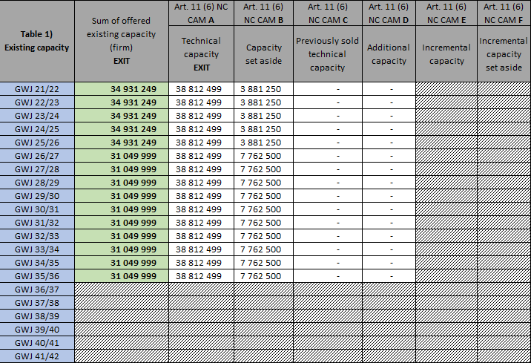

Table 2: Depiction of the technically available capacity of GAZ-SYSTEM to be made available for the Offer-level (kWh/h/y) on the IP Mallnow (exit):

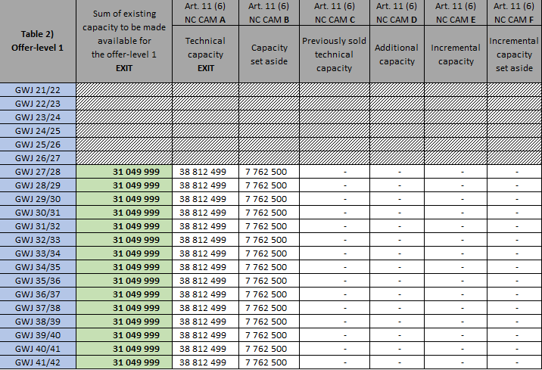
Table 3: Depiction of the common offer of existing capacity and of the common offer of Offer-level 1 (kWh/h/y) for the marketing of bundled capacity in 2021 for GAZ-SYSTEM and GASCADE on the IP Mallnow in direction Trading Hub Europe, taking into account CAM NC obligation to set aside capacity.

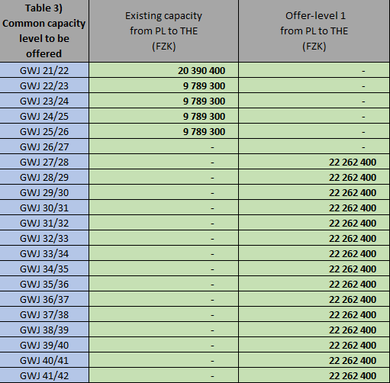

Terms and Conditions for the Incremental Capacity Auction to be accepted by the network user for the acquisition of incremental capacity (Art. 28 (1) (b) NC CAM)

According to Article 28 (1) (b) NC CAM for the participation in the incremental capacity auctions in 2021, general rules and conditions for each TSO have to be accepted.

3.1. Terms and Conditions for the Incremental Capacity Auction on the German side of the border

The draft of the supplementary terms and conditions (EGB) is enclosed with this document as Annex 3.

3.2. Terms and Conditions for the Incremental Capacity Auction on the Polish side of the border
The draft of “General terms and conditions of participation and access to capacity in the binding phase of capacity allocation corresponding to incremental capacity on the German side of the border between Poland TGPS (Transit Gas Pipeline System) and Germany (Trading Hub Europe)” (INC GT&C) is enclosed with this document as Annex 5.

Timetable for the incremental capacity project (Art. 28 (1) (c) NC CAM)

According to Article 28 (1) (c) NC CAM, GASCADE and GAZ-SYSTEM request to approve the following timetable for its incremental capacity project.
The further procedure within the scope of the ongoing process cycle can be seen as follows and present the latest possible deadlines according to NC CAM with regard to submitting the project proposal to NRAs as well as 6-months period of issuing coordinated decisions by NRAs:
Start | End | Description
10.08.2020 |  | Publication of the consultation documents
10.08.2020 | 10.09.2020 | Public consultation
11.09.2020 | 29.10.2020 | Planning of the offer levels by the TSO in close cooperation with the national regulatory authorities
 | 30.10.2020 | Submission of the project proposal to the national regulatory authorities
30.10.2020 | 30.04.2021 | Processing of the project proposal by the national regulatory authorities
 | 30.04.2021 | Approval and publication of the necessary parameters by the national regulatory authorities pursuant to Art. 28 (1) NC CAM
30.04.2021 | 04.05.2021 | Adjustment of the offer levels by the TSO to the stipulations of the national regulatory authorities
05.05.2021 |  | Publication of the approved parameters, the capacity products and of the sample contract or the sample contracts for the capacities offered within the scope of the network expansion project
05.07.2021 |  | Annual auction; the economic test will be carried out after completion of the annual auction
Table 3: Provisional time planning
The stated dates are provisional and can therefore be subjected to changes, especially should submissions to NRAs take place earlier and/or NRAs administrative procedure is completed earlier that in 6-month period.
The projects described below will be initiated after completion of the annual auctions in July 2021. Operational readiness of all technical measures is envisaged for the 1 October 2027 – under the presumption that the economic test conducted after the auctions is successful.
With a positive result of the economic test, allocated capacity will subsequently flow into the process for the creation of the German network development Gas 2022-2032 and will be taken into consideration in the scenario framework as well as with the (national) modelling.
The milestones are available in Table 4.
Milestones | Years of completion of project phases of the measures
Project concept | 2021
Basic evaluation/feasibility review | 2021-2022
Design planning | 2022-2023
Preparation of general planning procedure | 2022
Implementation of general planning procedure | 2023-2024
Preparation of Federal Emission Control Act (BImSchG) | 2023
Property acquisition | 2025
Preparation of plan approval procedure | 2023
Implementation of plan approval procedure | 2024-2025
Acquisition of right of way | 2025-2026
Implementation of Federal Emission Control Act (BImSchG) | 2024-2025
Construction approval process | 2025
Material and service procurement | 2023-2026
Preparation and start of construction | 2025-2026
Assembly/construction | 2025-2027
Commissioning | 2027
Project conclusion/completion | 2028
Table 4: Milestones in the implementation schedule of technical measures
Description of the project on German side (GASCADE)
The enquiry was made from the Gas Year 2022/2023 up to and including the Gas Year 2036/2037. However, due to extensive expansion measures for the realization of the capacity upgrade the provision of the capacity is only possible from the Gas Year 2027/2028.
In total, the technical studies of the present cycle for incremental capacity considered 47 scenarios, each based on a different combination of projects based on non-binding demand indications. The expansion measures were developed under the presumption that all non-binding requested capacities are booked and the economic tests are carried out successfully. In this document only the measures of the maximum scenario are described in the text, which are also caused by the requested capacity listed above. All expansion measures of the maximum scenario are shown in Figure 1. A detailed breakdown of costs is not provided here. The basis of the listed expansion measures is the infrastructure contained in the draft document for the network development plan Gas 2020–2030 (published on 1 July 2020; hereinafter “NEP”) including the network expansion measures resulting from the so called "basic variant". The investment costs concern initial estimates. In addition to the cost of the investment, there are operating costs for propellant, which are necessary in order to operate the compressors. The annual costs are stated below for the maximum scenario. Besides the commodity, these costs also include the natural gas tax as well as the CO2 costs.
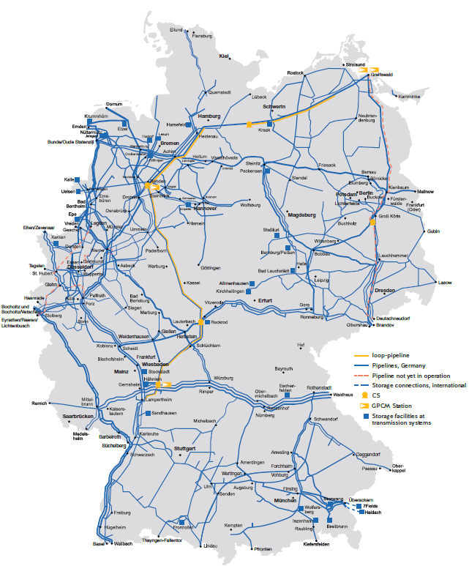
Figure 1: Expansion Measures for the Maximum Scenario

The following expansion measures are necessary on the EUGAL gas pipeline: The compressor station Radeland II must be modified. The investments amount to approx. €m 16. In total, the additional investments on this section of the pipeline amount to approx. €m 16.
The following measures are necessary on the NEL pipeline east of the Achim shut-off station: A compressor station with a compressor capacity of approx. 75 MW. This is already included in the NEP with a compressor capacity of 50 MW (VDS NEL (middle), ID No. 633-01). The additional investments amount to approx. €m 63. A loop pipeline with a length of approx. 85 km in DN 1400 is to be erected east of the compressor station. The investments amount to approx. €m 360. A loop pipeline with a length of approx. 57 km in DN 1400 is to be erected west of the compressor station, which ends on the Achim shut-off station. The investments amount to approx. €m 242. In total, the additional investments on this section of the pipeline amount to approx. €m 665. The annual costs for propellant for this section are approx. €m 19.6.
An alternative using two compressor stations was considered: One station with approx. 99 MW, of which a compressor capacity of 50 MW is already included in the NEP (VDS NEL (centre), ID-No. 633-01), and a further station with 99 MW near Buchholz. The additional investments for this variant were approx. €m 360 compared to the NEP. The annual operating costs here were as a max. approx. €m 210. This variant is not being further pursued at present. The TSO reserve the right to come back to this variant with the concrete design of the measures within the scope of the creation of the NEP Gas 2022-2032.
The following measure is necessary on the NEL pipeline west of the Achim shut-off station: A loop pipeline with a length of approx. 67 km in DN 1400 is to be erected. Of this 52 km in DN 1400 are already included in the NEP (NEL pipeline West, ID No. 634-01). The additional investments amount to approx. €m 118. In total the additional investments on this section of the pipeline amount to approx. €m 118.
The following expansion measures are necessary on the MIDAL pipeline: The Rehden compressor station must be extended by a compressor capacity of approx. 48 MW. The investments amount to approx. €m 250. A GPRM plant with a plant capacity of 2.2 million Nm³/h is to be additionally erected in Rehden. The investments amount to approx. €m 17. A loop pipeline with a length of approx. 260 km in DN 1400 is to be erected from Rehden to Reckrod. Of this 61 km are already included in the NEP (MIDAL pipeline middle north, ID No. 627-01; MIDAL pipeline middle south, ID No. 628-01). The additional investments amount to approx. €m 905. A compressor station with a compressor capacity of 84MW is to be erected near Reckrod. This is already included in the NEP with a compressor capacity of 36 MW (VDS Reckrod, ID No. 629-01). The additional investments amount to approx. €m 145. A loop pipeline with a length of approx. 200 km in DN 1400 is to be erected from Reckrod to Lampertheim. Of this 115 km in DN 1000 are already included in the NEP (Wirtheim-Lampertheim pipeline, ID No. 609-01). The additional investments amount to approx. €m 535. A compressor station with a compressor capacity of approx. 46 MW is to be erected near Herchenrode. The investments amount to approx. €m 180. In addition, a GPRM plant with a plant capacity of approx. 4 million Nm³/h is to be erected in Herchenrode. The investments amount to approx. €m 31. In total the additional investments on this section of the pipeline amount to approx. €m 2,063. The annual costs for propellant for this section are approx. €m 33.
Due to the large number of non-binding demand indications for incremental capacity, depending on the booking behaviour in the annual auctions 2021 and respectively within the scope of the alternative allocation mechanism for the RU-THE incremental project, there are interdependencies with regard to the project costs to be allocated. Depending on the incremental capacity to be provided on a network section, synergies or dyssynergies may arise. Synergies essentially arise in this case through economies of scale. The larger respectively the standard diameter of a loop pipeline is chosen, the lower the specific transport costs will be, as a rule, with the same relative capacity utilisation. Dyssynergies primarily arise from leapfrogging investments, e.g. if only the combined additional capacity requirements for several enquiries trigger, for example, a dimensioning leap in a pipeline measure. The cost allocation per expansion measure is carried out broken down according to the provided capacity. The dependencies of the projects are shown in Annex 1 to this consultation document.
The costs that are to be compared with the bookings that are submitted binding will therefore only be known finally after execution of the annual auctions and the alternative allocation mechanism.

Description of the project on Polish side (GAZ-SYSTEM)

Since the upgrade from DZK to FZK was requested only on German side of the entry-exit system and the existing capacity on the Polish side is already sufficient and will stay the same, there are no investment measures to be taken on Polish side of the entry-exit system and thus GAZ-SYSTEM does not submit any timeline of the incremental project.

Parameters of the economic test (Art. 28 (1) (d) in conjunction with Art. 22 (1) NC CAM)

Parameters of the economic test on the German side of the border

Economic test - GASCADE
For the economic test pursuant to Art. 22 NC CAM the BNetzA has created and published a calculation tool in order to improve the transparency. This was used by the TSO for the calculations presented below.
Pursuant to Subclause 1 of the operative part of the resolution of the BK 9 (ref. no. BK9-17/609) with the title INKA the economic test is carried out for each offer level of a project for incremental capacity pursuant to Art. 22 NC CAM by the BNetzA. In Part II of the stipulation resolution the BNetzA states that the economic test is an object of the project proposal and all principle questions of the economic test are to be clarified there. The following principle questions of the economic test must be defined still:

- Derecognition requirement of existing capacity products
- Economic test of the offer levels

GASCADE is therefore planning to apply for the following procedure for the conducting of the economic test at the BNetzA:

Derecognition Requirement of Existing Capacity Products
Pursuant to Art. 22 (1) (a) Subclause i NC CAM the binding requested incremental capacities to be created and pursuant to Art. 22 (1) (a) Subclause ii NC CAM the binding requested existing capacities should flow into the economic test.
In order to ensure an efficient network expansion it is to be examined by coordination with the BNetzA as a prerequisite for the start of the economic test whether the available capacity products (existing capacity) have been derecognised in the respective Gas Year pursuant to the project application. If the existing capacity has been derecognised in the respective Gas Year the quantity of the binding requested incremental capacity to be created shall be entered in (kWh/h)/annum per Gas Year in the BNetzA-Tool for testing of the economic. If the existing capacity has not been derecognised in a Gas Year the prerequisite for conducting the economic test does not exist for this Gas Year. No quantities will be entered in the economic test for the respective Gas Year.

The information regarding the booking situation of the existing capacities will be made available to the BNetzA by the FNB concerned. The examination whether the condition of the derecognition of the existing capacity has been fulfilled in the respective Gas Year shall be carried out by the BNetzA.

Economic Test of the Offer Level
As in this cycle for incremental capacity six projects will be analysed for new freely allocable incremental capacity, as described under II.1. there are comprehensive overlappings of the measures, which are necessary in order to be able to offer the capacity at the various market area borders. Therefore, an individual analysis of the enquiries with the associated measures is not target-oriented. The procedure, which the TSO have agreed upon in order to depict all possible booking scenarios, is described below.

In total, in the current cycle an enquiry is made for incremental capacity at four market area borders. At the market area border to Russia, in addition to incremental capacity, at the IPs Greifswald and Lubmin II an enquiry was respectively made for a capacity upgrade from existing DZK to FZK. Consequently, in the current incremental cycle offer levels can be booked for the following projects:

- Poland TGPS
- Russian Federation (combined in an alternative allocation mechanism)
- The Netherlands
- Russian Federation/Greifswald (capacity upgrade)
- Russian Federation/Lubmin II (capacity upgrade)
- Denmark

One offer level exists for each of these six projects. An enquiry can be made independently for each of the offer levels and pass the economic test. As a result, all combinations of positive and negative economic tests are conceivable. Which of the aforementioned enquiries are actually made binding can only be determined after the auctions or the evaluation of the alternative allocation mechanism.

In order to guarantee an efficient network expansion, the TSOs have depicted all possible combinations of enquiries and determined the need for expansion respectively necessary for this. The overview of all 47 combinations is listed in Annex 1. The costs of a necessary expansion measure including operating costs will be allocated to the enquiries causing this measure respectively in the ratio of the requested capacity. The present value of the sum of
these pro rata costs for specific measures results in the total allowed increase in the revenue cap (hereinafter “EOG”) assumed for a project in the economic test.

24 scenarios of combinations are derived for each enquiry with enquiries at the other market area borders. Each of these scenarios has following specific parts, which are listed in Annex 4:
- f-factor
- Present value of the estimated increase in the EOG
- Mandatory minimum premium

When conducting the economic test with the BNetzA-Tool it must first of all be determined which of the 47 booking scenarios has occurred in order to subsequently enter the three parts listed above in the tool for the economic calculation.

f-factor - GASCADE
According to Article 27 (3) NC CAM the consultation shall cover the level of user commitments, expressed as an estimate of the f-factor in accordance with Article 23, which, after having consulted with the transmission system operators, is proposed and subsequently approved by the concerned national regulatory authorities.
The f-factor for each offer level is stipulated by the national regulatory authorities by taking the following aspects into consideration (Art. 23 (1) NC CAM):
- the quantity of technical capacity, which will be withheld pursuant to Art. 8 (8) and (9);
- the positive external effects of the project for new capacity to be created on the market or the transmission network or both;
- the term of the binding commitments of the network users for the requested capacity compared to the commercial useful life of the plant;
- the expected continued existence of the demand for the capacity, which is created by the project for new capacity to be created, after the end of the time horizon used as a basis in the economic test.
For the economic test pursuant to Art. 22 NC CAM the BNetzA has created and published a calculation tool in order to improve the transparency (hereinafter referred to as "BNetzA-Tool"). The result of the completed BNetzA-Tool with the data relating to the offer levels analysed here is enclosed with this consultation document as Annex.
The BNetzA-Tool contains mathematical evaluations for the determination of the f-factor. The f-factor is produced hereby from the ratio of the present value of the binding commitment of network users to the contracting of capacities over the time horizon of the first annual auction, in which the respective new capacities to be created were offered, pursuant to Art. 22 (1) (a) NC CAM at the present value of all expected commitments of network users to the contracting of the respective capacities.
The most recent currently known reference price is estimated in the BNetzA-Tool as estimated reference price pursuant to Art. 22 (1) (a) Subclause i NC CAM and is updated until the respective year. Since inflation is not taken into account when determining the increase in the revenue cap of the pertinent TSO resulting from the incremental capacities in each offer level, the inflation index for the reference prices was also set at 0 percent.
The proposed f-factor was determined as follows:
- Pursuant to Art. 8 (8) NC CAM and KARLA Gas, technically available capacity is set aside in the amount of 20% of the incremental technical capacity contained in the pertinent offer level. It is assumed here that the set aside capacities will be fully utilised in subsequent years as part of the marketing of the capacities and will therefore also be booked. Since from Gas Year 2035/36 existing, booked capacity can be upgraded up to 100 %, the reservation quota of 20% is only taken into account for capacity which is offered starting from Gas Year 2036/2037. The f-factor should take into consideration that 100 % of reserved capacity is booked at a later time.
- Further positive external effects were not examined.
- Pursuant to Article 11 (3) NC CAM offer levels can be offered for new capacities to be created within the scope of the annual auctions for a maximum period of 15 years from the start of the operational use.
For the period of time from the Gas Year 2027/2028 up to and including Gas Year 2041/2042 it was assumed that the new capacities to be created that were offered in the annual auction 2021 will be fully booked.
The start of the operational use is envisaged for the year 2027. The commercial useful life of the plants was estimated in line with the regulatory and normal depreciation durations. The described investments refer to compressor stations as well as to the pipeline construction. Consequently, an average useful life of 45 years for pipelines in accordance with the Gas Network Charges Regulation (Gasnetzentgeltverordnung; GasNEV) is assumed. The start of the operational use is envisaged for 2027, the end of the operational use is for the time being assumed for Gas Year 2071/2072.
The gas infrastructure concerned in this procedure will be of great importance in the future energy market. Thus, the TSOs assume that the infrastructure will be reused for hydrogen. The transport of hydrogen is expected to result in a lower transport potential. As a result, the use of the infrastructure is assumed to be 65% for the period from Gas Year 2053/2054 to Gas Year 2071/72.
d) The decisive year for the determination of the time horizon of the commercial useful life and the economic test is 2072. No bookings were taken into consideration for the period of time from 2072.
The proposed f-factor is oriented to the occurred booking scenario and is included in Annex 4.
Reference price for determining the present value of the binding commitments of network users – GASCADE
The current forecast of the reference price is the reference price published in the BNetzA decision REGENT 2021 for freely allocable capacity (FZK) of the market area THE for 2023 in the amount of € 3.73/(kWh/h)/annum. This reference price is solely used in the economic test and is not a part of the contract.
Present value of the estimated increase in the allowed revenues due to capacity increase – GASCADE
The present value of the estimated increase in allowable revenue (EOG) depends on the amount and timing of the costs allocated to the project. The costs depend on the other projects for incremental capacity. The present value of the estimated increase in EOG is shown in Annex 4.
Mandatory minimum premium – GASCADE
Analogue to the f-factor and to the cash value of the estimated increase in the EOG the mandatory minimum premium also depends on which measures become necessary due to the marketing of incremental capacity to be created on 5 July 2021. Which mandatory minimum premium is to be applied for the corresponding booking scenario can be derived from Annex 4. Its amount is assessed in each scenario to the extent that the economic test can only be passed with a full booking of the capacity included in the offer level. This should also guarantee that the transport customer must not over-compensate the estimated increase in the EOG.

Parameters of the economic test on the Polish side of the border
As GAZ-SYSTEM does not bear any investment costs due to the fact that enough capacity is available on Polish side of the border, there is no need to set the f-factor and conduct the economic test. Thus, the results of the economic test on the German side of the border will be binding for the project on both sides of the border.

Possible extended time horizon for contracting incremental capacity (Art. 28 (1)(e) NC CAM)
Based on a common decision GASCADE and GAZ-SYSTEM agree, that for this incremental capacity project no extended time horizon for contracting incremental capacity is needed.

Alternative allocation mechanism (Art. 28 (1) (f) NC CAM)
GASCADE and GAZ-SYSTEM abstain from an application of an alternative allocation mechanism for the acquisition of incremental capacity according to Article 28 (1) (f) NC CAM. Based on a common decision, both network operators will apply the standard auction procedure via the Regional Booking Platform (RBP) for the acquisition of incremental capacity in 2021.

Application of a fixed price approach (Art. 28 (1) (g) NC CAM)
GASCADE and GAZ-SYSTEM abstain from the application of a fixed price approach for the acquisition of incremental capacity in 2021 according to Article 28 (1) (g) NC CAM.

- Contact data
GASCADE Gastransport GmbH | Operator Gazociągów Przesyłowych GAZ-SYSTEM S.A.
Michael Walkus | Paulina Buczek
Tel.: +49 561 934 2968 | Tel.: +48 22 220 18 22
Michael.Walkus@gascade.de | incremental@gaz-system.pl

Hereinafter named as „THE”. THE is the common German market area to be established as of 1 October 2021.
A non-binding demand indication for 9 629 000 kWh/h/y of freely allocable firm capacity (FZK) in addition to the existing bookable freely allocable firm capacities was indicated to GASCADE. In addition, an explanatory comment was provided by the requesting market participant: “Please note that the aim of this request is that starting from 01 Oct 2022 the requested IC shall be offered as FZK instead of DZK (DZK is currently 20.613 GWh/h in NEP 2020 Databank for years 2023+) to the extent that the total technical entry capacity of 38.812 GWh/h in Mallnow shall comprise of FZK in amount of 27.828 GWh/h and DZK in amount of 10.985 GWh/h). This request is not submitted as capacity upgrade, because the respective DZK is not booked. For avoidance of doubts, the requested IC shall be added to the technical capacity FZK of 18.199 GWh/h as published in NEP 2020 Databank for years 2023+.”
To be found under: https://www.fnb-gas-capacity.de/en/cycles/2019-2021-incremental-capacity-cycle/market-demand-assessment-reports/
To be found under: https://en.gaz-system.pl/centrum-prasowe/aktualnosci/informacja/artykul/203048/

